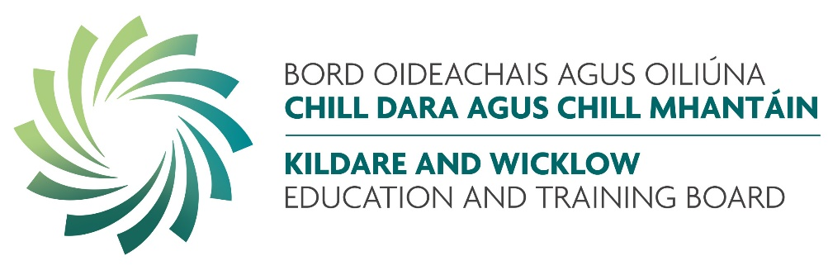

Section 22 of the Protected Disclosures Act, 2014 and Protected Disclosure (Amendment) Act 2022 requires public bodies to publish an annual report setting out the number of protected disclosures received in the preceding year and the action taken (if any). This report must not result in persons making disclosures being identifiable.

This report covers the period January 1st 2025 to December 31st 2025.

KWETB received one disclosure under the Protected Disclosures Act for the reporting year 2025. Following a thorough screening, it was confirmed there was not sufficient evidence to support the disclosure made and accordingly, it was not deemed to meet the criteria of a valid protected disclosure under the Act.

The Senior Management Team of KWETB are fully committed to KWETB maintaining the highest standards of integrity and probity and ensuring that the culture and working environment of KWETB encourage, facilitate and support any worker of the organisation to ‘speak up’ on any issue that could impinge on the organisations ability to carry out its roles and responsibilities to the high standard expected.

We are also committed to ensuring that any such issue raised by a worker of KWETB will be dealt with professionally and appropriately, adhering to standards and principles as outlined in the Act.

The document entitled KWETB Protected Disclosure Policy and Procedures is located here

