**APPLICATION FORM**

**Please note:**

The Application Form must be **TYPED.** Handwritten forms will not be accepted.

All questions must be answered.

Do not change the question numbers or sequence.

Boxes may be expanded as required – please comply with maximum word count requirements.

**No letter of application, CV or written reference should accompany this form.**

**Application for the post of: Back to Education Initiative Adult Educator – Mid Kildare**

**13 hours per week – Initial location:** Naas & Newbridge FETC

# 1. PERSONAL DETAILS

|  |  |  |
| --- | --- | --- |
| **First Name:** |  | **Surname:** |
|  |  |  |
| **Home Address:** |  | **Correspondence Address: *(if different)*** |
|  |  |  |
| **Home Phone Nu** | **mber:** | **Mobile Phone Number:** |
|  |  |  |
| **Email Address:** |  | |

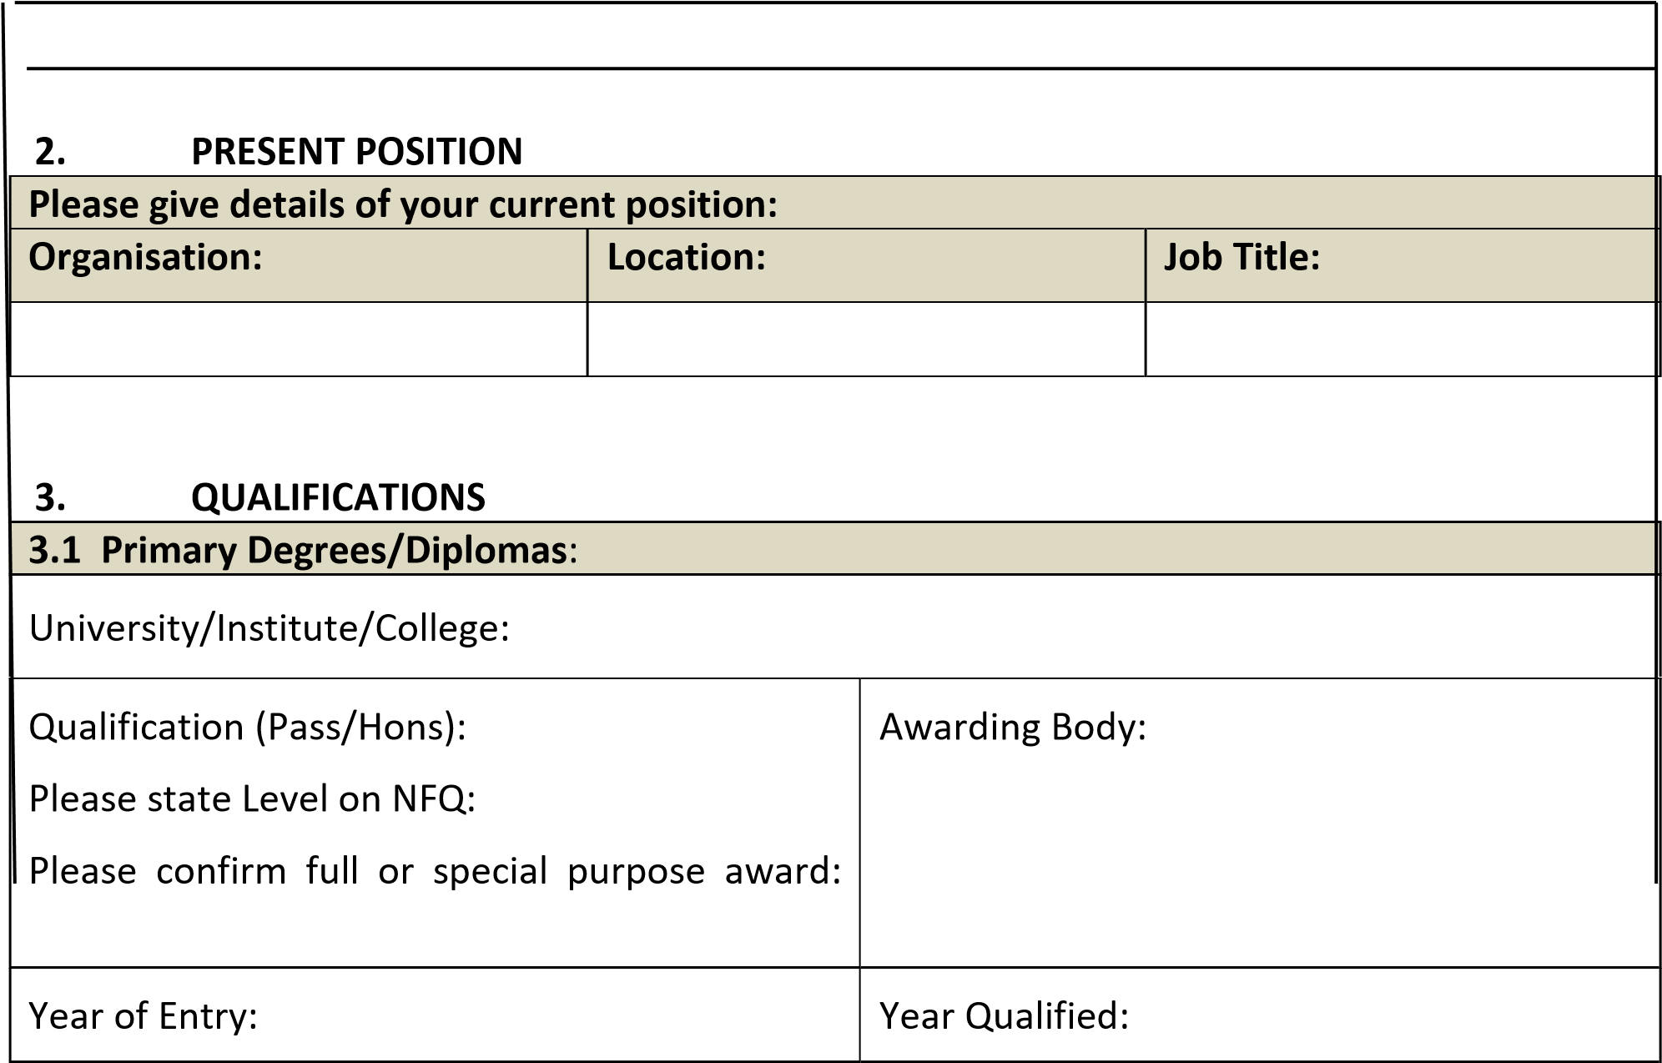

|  |  |
| --- | --- |
| Subjects studied: | |
|  |  |
|  |  |

|  |  |
| --- | --- |
| **3.2 Post Graduate Degrees/Diplomas:** |  |
| University/Institute/College: |  |
| Qualification(Pass/Hons): | Awarding Body: |
| Year of Entry: | Year Qualified: |
| Subjects studied: |  |
|  |  |
|  |  |
| University/Institute/College: |  |
| Qualification (Pass/Hons): | Awarding Body: |
| Year of Entry: | Year Qualified: |
| Subjects studied: |  |
|  |  |
|  |  |

|  |  |  |
| --- | --- | --- |
| **3.3 Other Skills Training/Courses relevant to this Post:** | |  |
| Year attended | Title of Skills Training | Training Body |
|  |  |  |
|  |  |  |
|  |  |  |
|  |  |  |
|  |  |  |

# 4. PROFESSIONAL MANAGEMENT/LEADERSHIP DEVELOPMENT

|  |  |  |  |
| --- | --- | --- | --- |
| **4.1 Professional Management/Leadership Development:**  List any management/leadership courses not included in Section 3 above. Please include dates of the relevant training and duration of these courses as well as additional qualifications. Start with the most recent and work backwards. | | | |
| ***Name of Course*** | ***Name of Organisation/Institution running course*** | ***Length of Course*** | ***Year*** |
|  |  |  |  |
|  |  |  |  |
|  |  |  |  |
|  |  |  |  |
|  |  |  |  |
|  |  |  |  |
|  |  |  |  |

|  |
| --- |
| **4.2** **What key skills and knowledge have you developed as a result of these courses that are relevant to this position?** |
|  |

**5. TEACHING, TUTORING AND OTHER RELEVANT EXPERIENCE**

|  |  |  |  |  |
| --- | --- | --- | --- | --- |
| **5.1 Please provide details of your work history beginning with the most recent position:** | | | | |
| Dates (From/To) | Name & Address of Employer | Position Held  &  Whole-time or Part-time | Summary of Main Duties | Reasons for Leaving |
|  |  |  |  |  |
|  |  |  |  |  |
|  |  |  |  |  |

|  |  |  |  |
| --- | --- | --- | --- |
| **5.3 Other relevant experience (ie Social/Business) beginning with the most recent.** | | | |
| Dates  From/To | Position | Education Centre or other Institution | Responsibilities |
|  |  |  |  |
|  |  |  |  |
|  |  |  |  |

|  |
| --- |
| **5.4 Outline briefly your three greatest achievements with respect to the above responsibilities:** |
|  |

|  |
| --- |
| **5.6 What aspects of your most recent experience, outlined above, have prepared you for the role of BTEI Adult Educator?** |
|  |

# 6. THE ROLE AND FUNCTION OF BTIE ADULT EDUCATOR

A number of key competencies have been identified as being essential for the effective performance of the role and function of **BTEI ADULT EDUCATOR**

These competencies are as follows:

6.1 Team Work

6.2 Information Management/Processing

6.3 Delivery of Results

6.4 Customer Service and Communication Skills

6.5 Specialist Knowledge, Expertise and Self Development

6.6 Drive and Commitment to Public Service Values

**Outline an example(s) on the following pages of how and where you have displayed each of these competencies (no more than 300 words per competency). The example(s) may be drawn from your experience in various settings including professional, social, sporting or voluntary.**

|  |
| --- |
| **6.1 Team Work** |
|  |

|  |
| --- |
| **6.2 Information Management/Processing** |
|  |

|  |
| --- |
| **6.3** **Delivery of Results** |
|  |

|  |
| --- |
| **6.4 Customer Service and Communication Skills** |
|  |

|  |
| --- |
| **6.5 Specialist Knowledge, Expertise and Self Development** |
|  |

|  |
| --- |
| **6.6 Drive and Commitment to Public Service Values** |
|  |

# 7. SUPPORTING STATEMENT

This section is for you to provide further information in support of your application. You should demonstrate why you have applied for the position and outline any other knowledge/expertise or attributes which you consider pertinent to the role of **BTEI ADULT EDUCATOR**

|  |
| --- |
|  |

# 8. REFERENCES

|  |  |
| --- | --- |
| Please provide the names and addresses of two referees from whom Kildare and Wicklow ETB can request references on your behalf. One should be your **most recent manager**/employer and one should be a **recent manager**/employer. Both referees should have been in a position of responsibility within the employing organisation(s) . They must not be related to you, or be known to you as a friend.  *[****Please note: your referees will be contacted without further communication with you. References may be taken up prior to interview. All appointments are subject to references satisfactory to Kildare and Wicklow ETB].*** | |
| Name:  Position:  Address:      Tel No:  E-mail Address: | Name:  Position:  Address:      Tel No:  E-mail Address: |

**Please note that any form of canvassing will disqualify your application.**

# DECLARATION AND SIGNATURE

* You are required to sign the declaration below certifying that all information you have provided is accurate.
* The Selection Board may wish to check any of the details you have provided.
* Providing incorrect information or deliberately concealing any relevant facts may result in disqualification from the selection process or, where discovery is made after an appointment, in summary dismissal.

I declare that the information supplied in this application form is accurate and true.

Signed ______________________________________________ Date ________________

A fully completed official application form should be submitted via email to jobapplications@kwetb.ie no later than **12 noon on Thursday, 31st October 2024**.

Please note the following

* Short listing may apply.
* Canvassing by or on behalf of the candidate will automatically disqualify.
* Late applications will not be accepted.
* It is the responsibility of the candidate to ensure that the application form is received at the stated email address before the stated deadline. It is recommended applicants request a delivery receipt when sending their application.
* Any technical difficulties encountered by the sender when submitting an application are not the responsibility of the KWETB.

HR Department KWETB

# COMPLETING A COMPETENCY BASED APPLICATION FORM

A Competency Based Application Form requires you, the candidate, to describe some of your personal achievements to-date that demonstrate certain competencies (necessary skills and qualities) required for the position you are applying for (e.g. Leader of Education and Learning, Leader of Centre Development, Communication Skills etc.). All question areas must be completed.

A definition of a skill or quality is given for each competency. You are then asked to describe a situation, from your own experience, which you think is the best example of what **YOU** have done which demonstrates this skill or quality. It is essential that you describe how **you** demonstrated the skill or quality in question.

You are advised to structure what you write so that you give specific information about what you have done - for example, do not simply say that “X was successful”, describe exactly what you did and how you demonstrated the skill or quality in question.

For each example please include the following:

1. the nature of the task, problem or objective;
2. what you actually did and how you demonstrated the skill or quality (and, where appropriate, the date you demonstrated it)
3. the outcome or result of the situation and your estimate of the proportion of credit you can claim for the outcome.

Please do not use the same example to illustrate your answer to more than two skill areas.

Please note that, should you be called to interview, the board may look for **additional examples** of where you demonstrated the skills required for this post so you should think of a number of examples of where you demonstrated each of the skills.