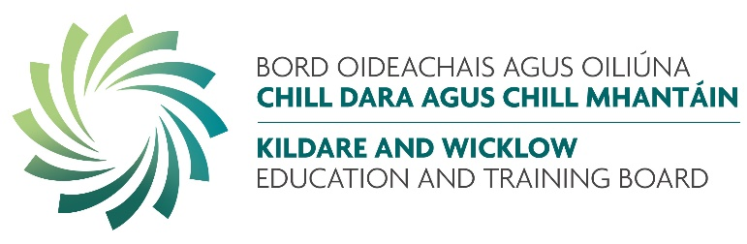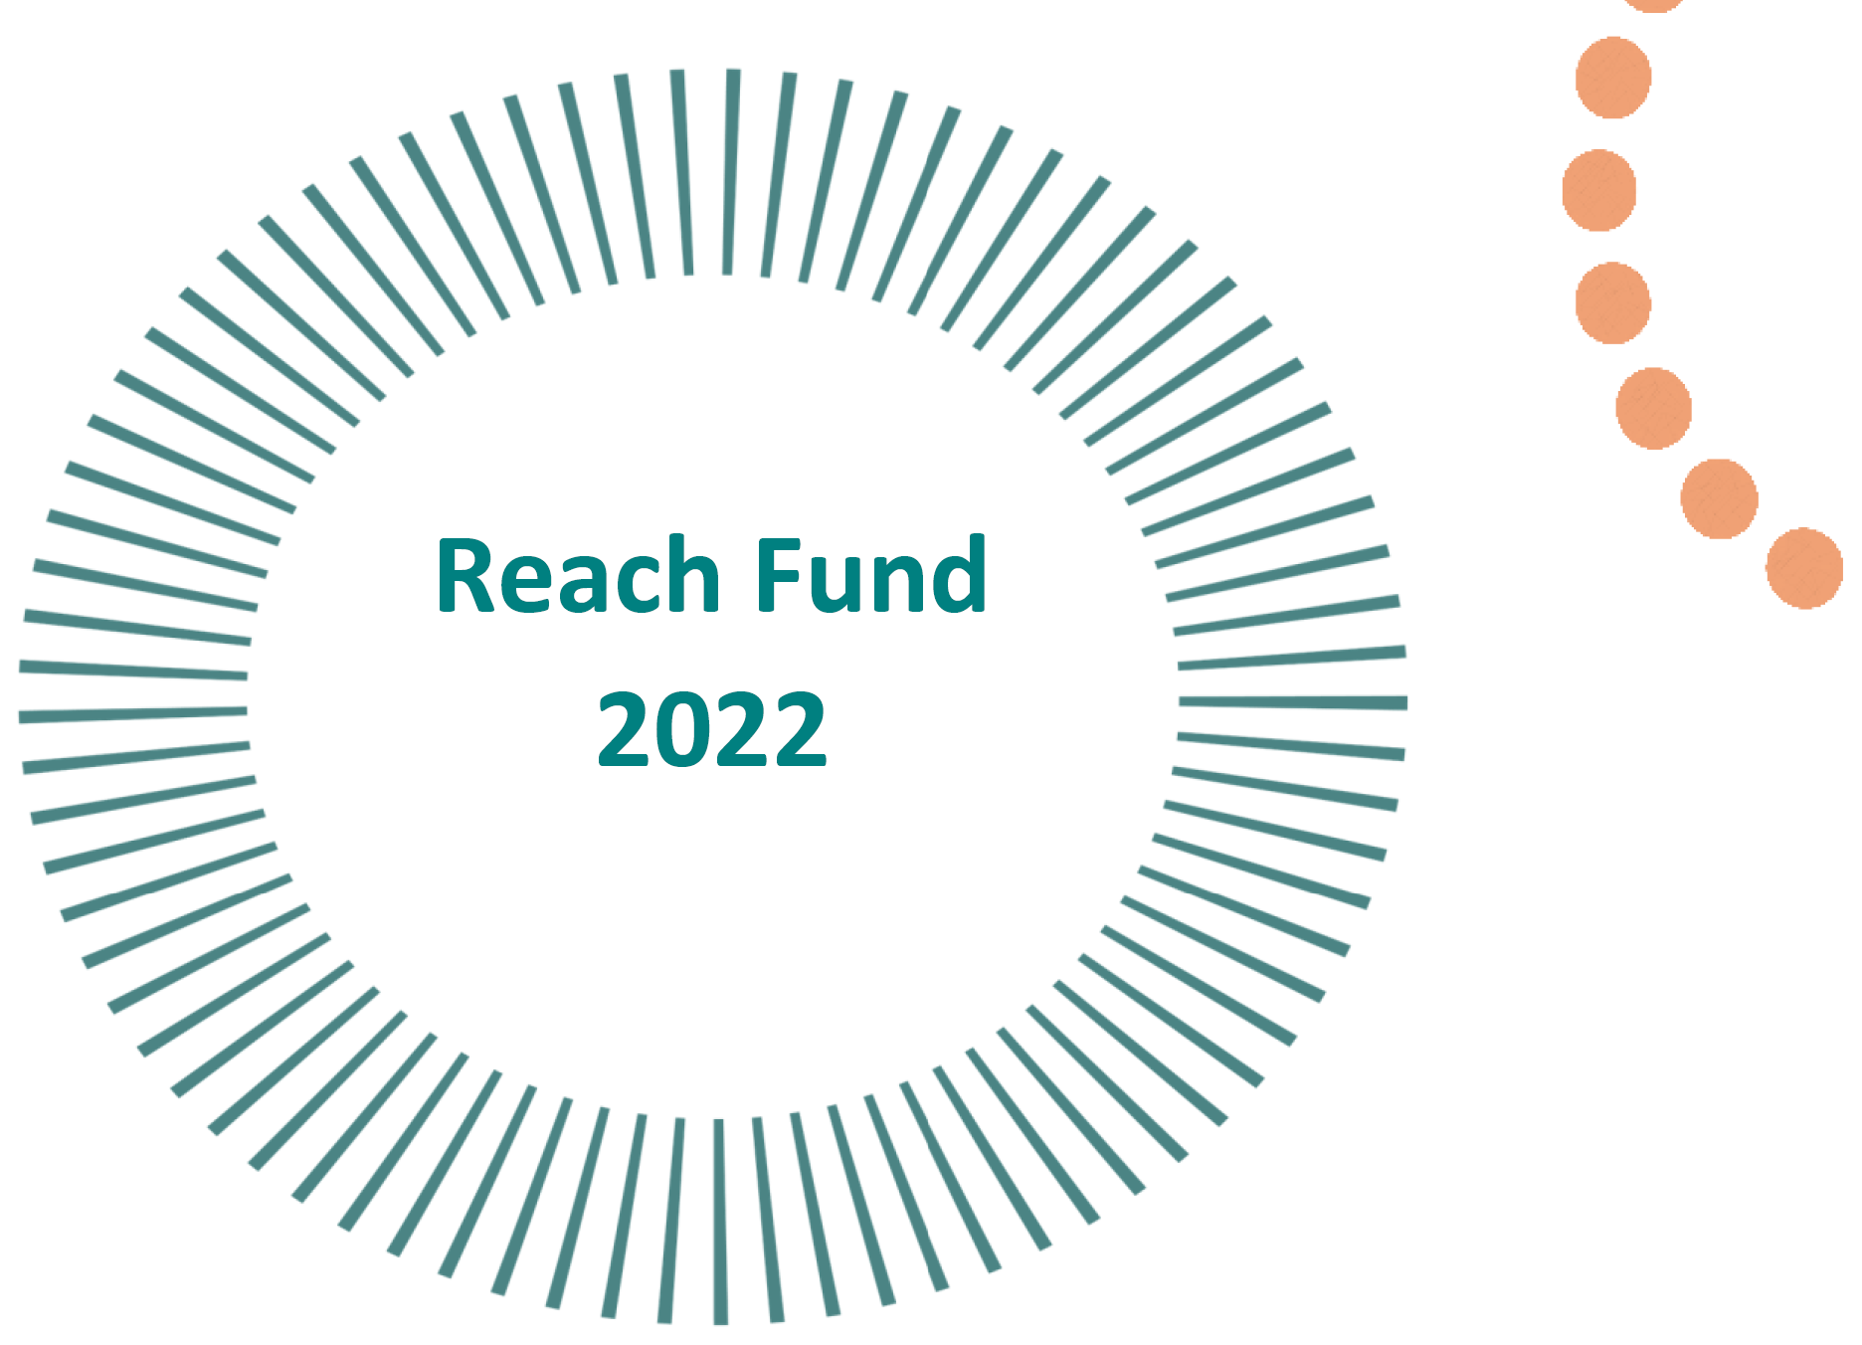
Reach Fund 2022
Call for Applications 2022
KWETB is now inviting applications for the fund from community education providers in the Kildare and Wicklow area.
The Reach Funder (formerly MAEDF) is funded by the Department of Further and Higher Education, Research, Innovation and Science and is administered by SOLAS, the further education and training authority, and the 16 local Education and Training Boards.
The aim of the Reach fund is to provide funding to support educationally disadvantaged learners in accessing and participating in community education.
It aims to increase the participation of disadvantaged learners, particularly those who are undertaking literacy and skills programmes.
The fund has a strong focus on building the digital infrastructure of community education providers, including providing devices and software, and increasing their capacity to deliver learning.
The fund was specifically designed to tackle inequalities and support access to community education and intended to address specific actions in the Adult Literacy for Life (ALL) Strategy to target funding on access to technology and devices, expand community access to wi-fi and broadband resources and to directly address unmet literacy needs.
Categories eligible for funding consideration for 2022 are:
Digital Technologies | Equality Awareness Raising | Refugee Support | Innovative Green Projects | Support Disadvantaged groups

REACH Guidelines and Applications Form are available here (Link to application form and guidelines).
Grant Administration
Funds are allocated by SOLAS to KWETB, who is responsible for the administration and management of funding within its region.

The closing date for applications is 5:00pm on 12th August 2022
Applications should be sent by email to reach@kwetb.ie

