Prompt Payments by Health Service Executive, the Local Authorities, State Agencies and all other Public Sector Bodies

Reporting Template pursuant to Government Commitments in the National Recovery Plan 2011-2014 and the EU/IMF Programme of Support for Ireland – Programme Documents

Parent Government Department: Department of Education & Skills

Quarterly Period Covered: July to September 2016

Public Sector Body: Kildare and Wicklow Education and Training Board

Details | Number | Value (€) | Percentage (%) of total number of payments made
Number of payments made within 15 days | 3979 | €5,431,189.28 | 84.55
Number of payments made within 16 days to 30 days | 695 | 571,510.59 | 14.76
Number of payments made in excess of 30 days | 32 | 25,476.08 | 00.68
Total payments made in Quarter | 4706 | €6,028,175.95 | 100%
Disputed Invoices
(see foot note)
Invoices received during the quarter and still under dispute at the end of the quarter

Signed: _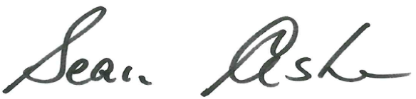_

Date: __7/10/2016_______________________

Please return completed template to PromptPaymentReturns@education.gov.ie

Phone No. (01) 8892188/8896653

