APPENDIX 1(b)

Prompt Payments by Public Sector Bodies

Reporting Template pursuant to Government Decision S29296 of 2 and 8 March 2011 and 28 March 2017 by:

The Health Service Executive, the Local Authorities, State Agencies and all other Public Sector Bodies, (excluding Commercial Semi State bodies)

Parent Government Department: Department of Education and Skills
Public Sector Body:
Quarterly Period Covered: July to September 2017

Details | Number | Value  (€) | Percentage (%) of  total number of payments made
Total payments made in Quarter | 4758 | 10,806,181.65 | 100%
Payments made within 15 days | 3837 | 9,961,118.49 | 80.64%
Payments made within  16 days to 30 days | 907 | 836,494.74 | 19.06%
Payments made in excess of  30 days that were subject to LPI and compensation costs | 14 | 8,568.72 | 00.30%
Payments made in excess of
30 days that were not subject to LPI and compensation costs
Amount of late payment interest (LPI) paid in Quarter | N/A | 562.50 | N/A
Amount of compensation costs paid in Quarter | N/A | 540.00 | N/A

Signed: 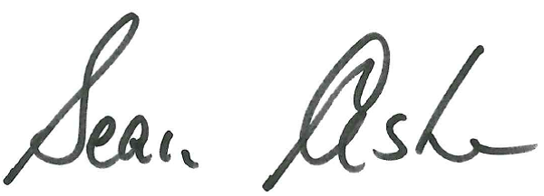

Date: 12/10/2017

Please return completed template to:
Parent Department: PromptPaymentReturns@education.gov.ie
Phone No. (01) 8892168

